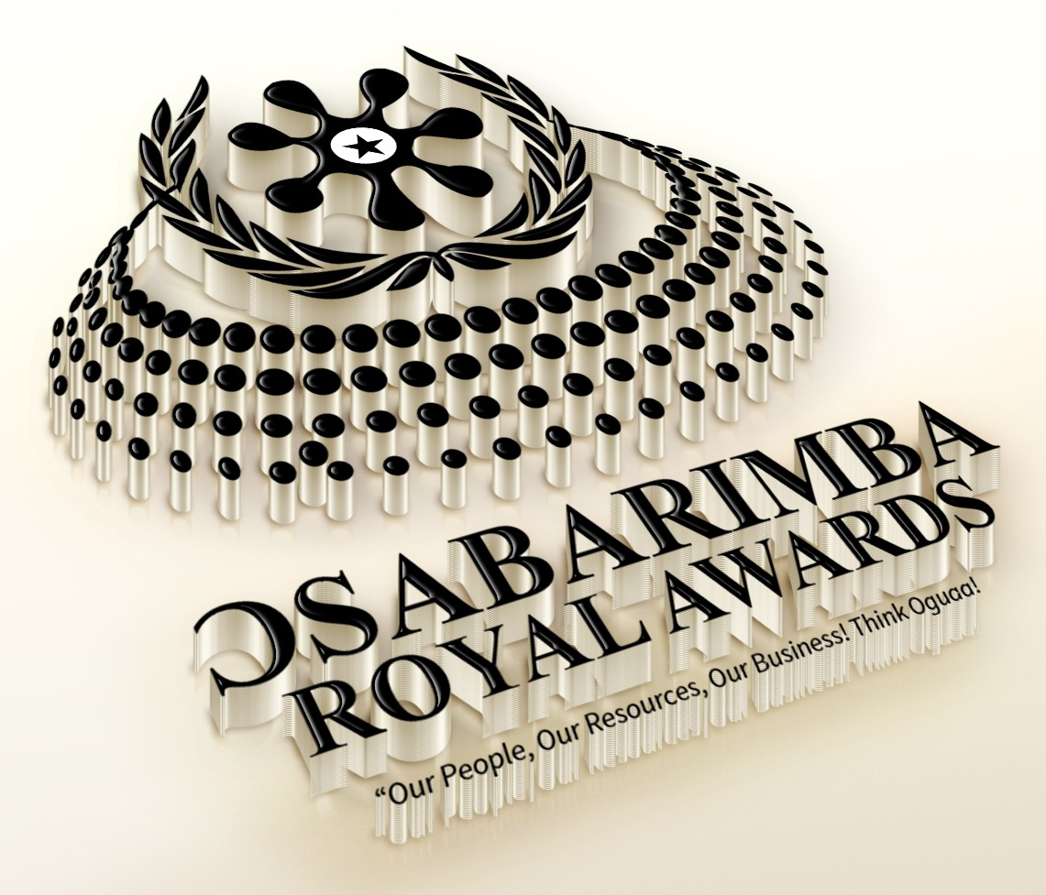
OSABARIMBA ROYAL AWARDS
7th Edition • Oguaa Traditional Area • Saturday, 23rd January 2027
“Our People, Our Resources, Our Business! Think Oguaa!”
SPONSORSHIP FORM

1. SPONSOR INFORMATION

Organisation Name:
Contact Person:
Address:
Phone Number:
Email Address:

2. SPONSORSHIP DETAILS

Category Name:
Amount / Value:

Sponsorship Level (please tick as applicable)
☐ Platinum Sponsor | ☐ Gold Sponsor
☐ Silver Sponsor | ☐ Bronze Sponsor
☐ Category Sponsor | ☐ In-Kind / Product Sponsor

Benefits Provided (please tick as applicable)
☐ Full-page advert in programme | ☐ Half-page advert in programme
☐ Award presentation opportunity | ☐ Logo placement
☐ Speaking opportunities | ☐ Other: ______________________

3. AGREEMENT TERMS

Duration:
Payment Terms:
Cancellation Policy:

4. SIGNATURES

Sponsor Representative (Signature)  Name & Date |  | Organising Committee Representative (Signature)  Name & Date

Kindly return the completed form to the Organising Committee • info@osabarimbaroyalawards.com

